Item 1
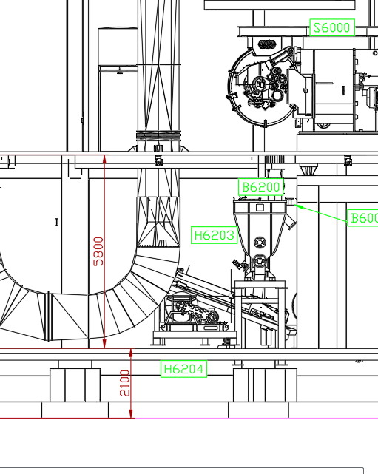 | 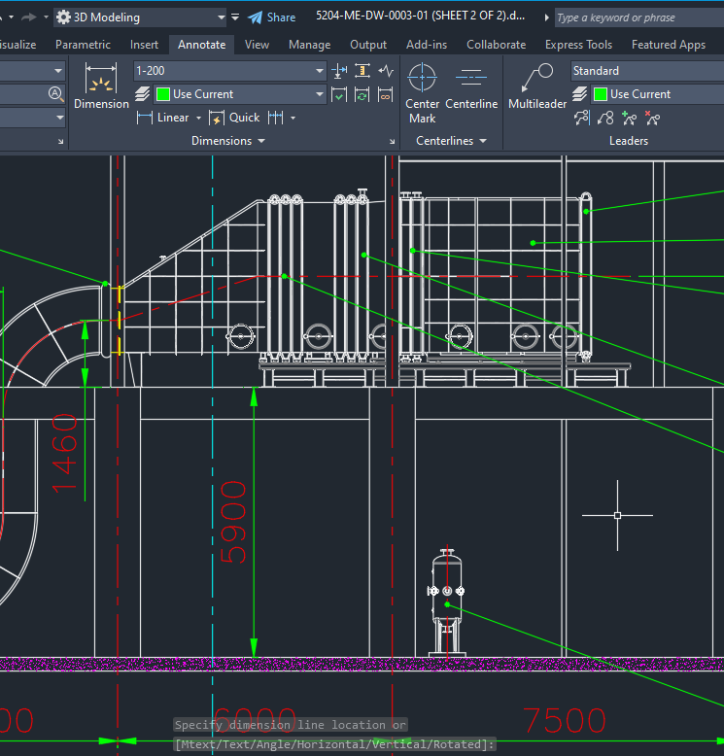
2D Client | 2D Microtec
Top of first ceiling +5.8m | Top of first ceiling +5.9m
Solution: Decrease the height of ceiling by Microtec
Affects:
- “Z” Position of starch cake inlet duct (against dryer duct)
- Increased intererence between Agitating element’s hopper and Peeler structure
Required action: Alex to confirm whether to go with +5.8 or +5.9 and hint Boda and Afradi for correction if necessary

Item 2
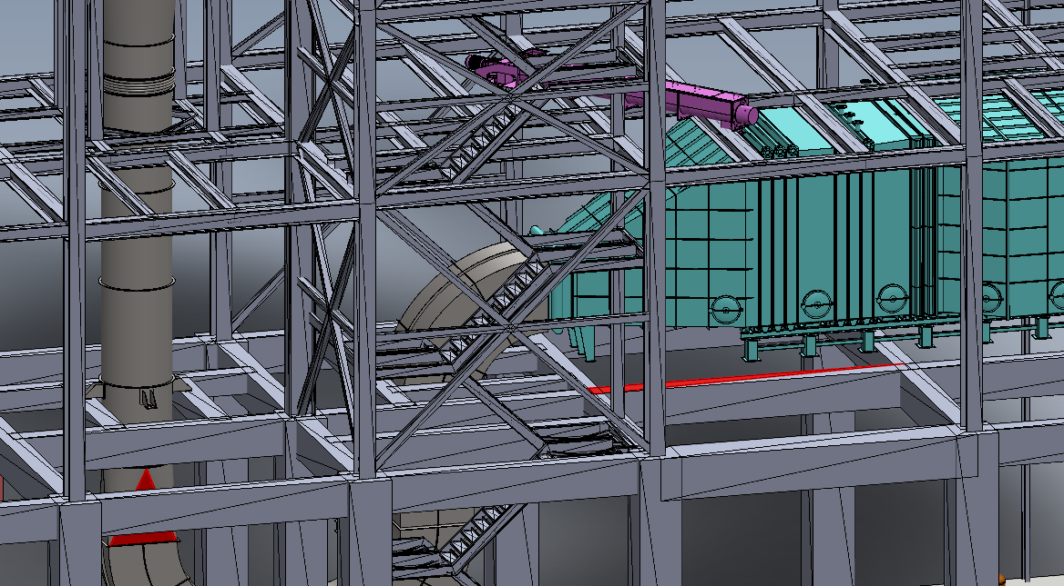
At the second ceiling, floor on the two sides of stair case box are not at the samle level , there is 130mm difference (at height)
WE HAVE CONSIDERED THE LEVEL DIFFERENCE BETWEEN CEILING 2 (STEEL) AND CEILING 1 (CONCRETE) IS 5370 mm, THIS IS USED AS A REFERNECE FOR EQUIPMENT SEATS
Required action: Alex to hint to client (For client information)

Item 3
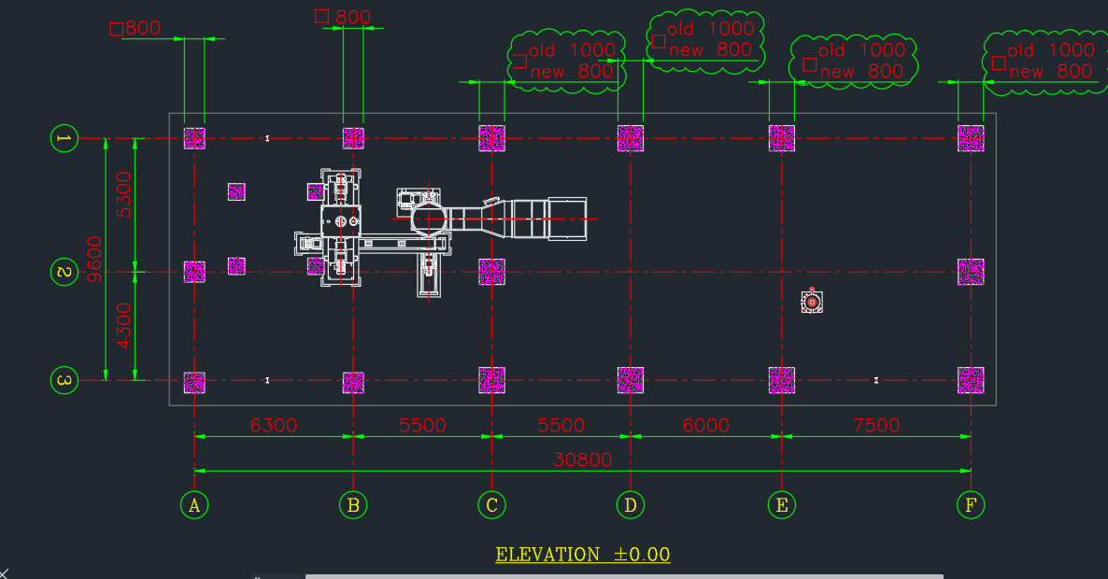
Issue: Columns on (C to F) / (1 to C) is considered 1000x1000, whereas its 800x800 by client
Action to be taken: Columns dimensions to be modified by Microtec

Required action: Alex to clarify with Boda and then hint for modificatin to Boda and Afradi

Item 4
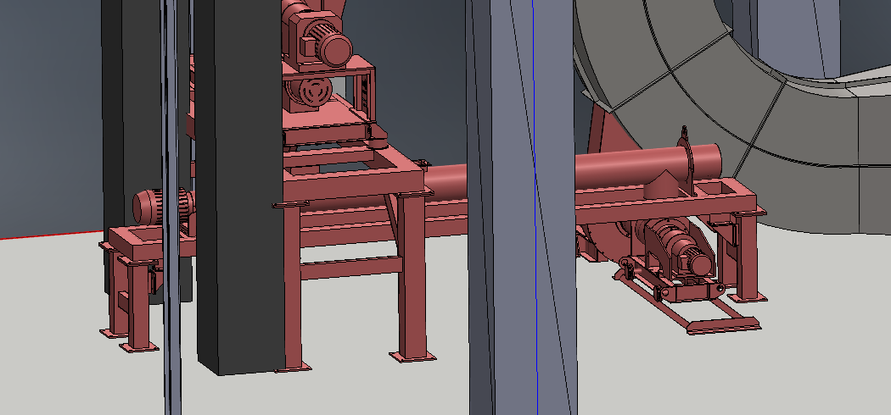
Issue: Agitating feeder base colides with concrete column (of peeler base) around 15cm
Possible modification:
- Base is too wide, width can be decreased
- Length of starch cake screw conveyor to be decreased about 12-20 cm

Item 5
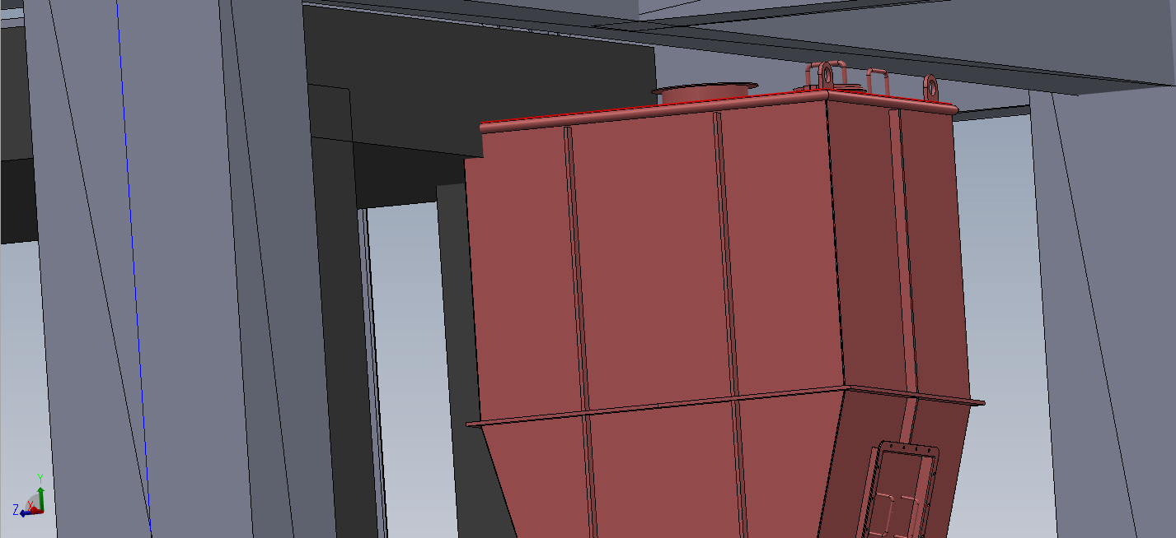
Issue: Agitating element colides with concrete ceiling (of peeler base) around 8cm
Possible modification:
- Peeler hight to be decreased by aroun 10 cm
- Length of starch cake screw conveyor to be decreased about 12-20 cm

Item 6

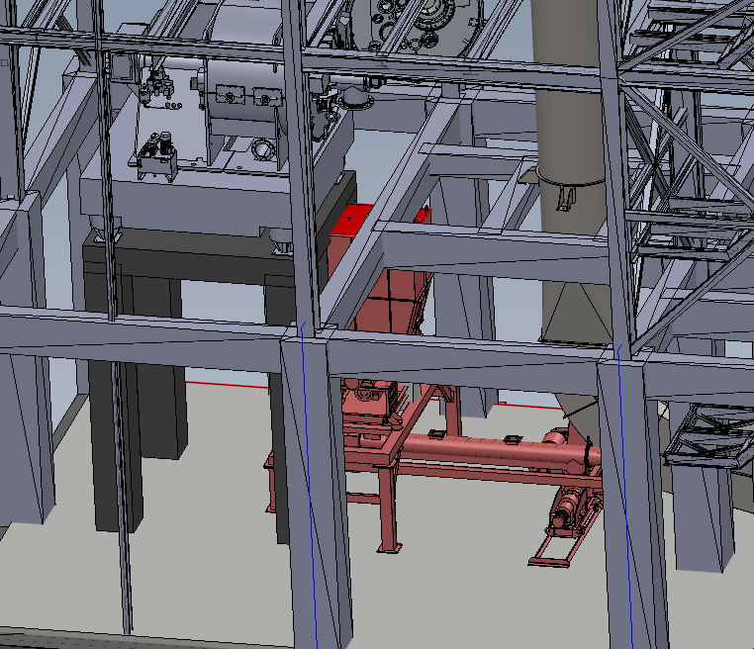
Issue:
- Peeler outlet port and agitating element inlet port are not coaxial, neither in X nor in Y directions. Specially in Y direction (Y is perpendicular to starch cake screw conveyor axis)
- Top opening can hardly be opened and removed, even if it could be removed, access to the top of agitating element is almost imposible
Possible modification:
- Peeler hight to be decreased by around 10 cm
- Design of concrete ceiling (+5.8) to be modified in order to provide access from top to agitating element’s hopper
- Opening to be brought to the side of the hopper
- Dry starch screw conveyor length to be decreased

Item 6- Continued
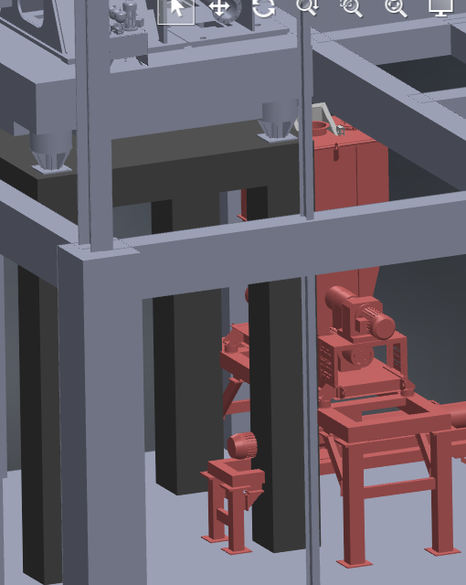

This is what happens when outlet port of peeler and inlet port of agitator be coaxial

Final conclusion: This part of plant better be redesigned in 3D
Required action: Alex to
- Ask client:
  - Whether the position of outlet port of peeler is final, Also the position and all dimenstions of concrete peeler base
  - Whether outlet port of peeler and inlet port of agitating element (hopper) should be coaxial
- Talk with Boda for remedies
- Advise Boda and Afradi for modifications
- It seems necessary that the connecting duct between peeler and agitating element be designed and manufactured by Microtec as scope of project

Equipments seat levels
EQUIPMENT NAME | SEATS ON LEVEL (m)- By Microtec  (After modifying from +5.9 to +5.8) | SEATS ON LEVEL (m)- By Client | Necessary action
Agitating element and feed vessel (B6200 & B6201) | +0.0 | +0.0 | -
Starch cake screw conveyor (B6202) | +0.0 | +0.0 | -
Starch cake feeder (B6203) | +0.0 | +0.0 | -
Starch cake blower (B6204) | +0.0 | +0.0 | -
Condensate tank (B6515) | +0.0 | +0.0 | -
Heater Assy. | +5.8 m | +5.8 | -
Dryer duct fixed bracket (#1) | +5.8 m | +5.8 | -
Dryed starch screw conveyor (H6513) | +11.17 | +11.7 | -
Dryer duct pin guided bracket (#2) | +14.7 | +14.7 | -
Dry starch receiving silo (B6512) | +14.7 | +14.7 | -
Starch dryer fan (V6515) | +14.7 | +14.7 | -
Dryer duct pin guided bracket (#3) | +19.6 | +19.6 | -
Fan duct bracket (Lower) | +19.6 | +19.6 | -
Dryer duct fixed bracket (#4) | +24.84 | +25.0 | To be clarified
Fan duct bracket (Upper) | +24.84 | +25.0 | To be clarified
Exhaust duct fixed bracket | +24.84 | +25.0 | To be clarified
Starch dryer cyclones (F6506 to F6511) | +24.84 | +25.0 | To be clarified

